ALTA VISTA RIDGE
2241 S. SH Business 121, Lewisville, TX 75067
972-906-8890
www.GABLES.com
“Taking care of the way people live”
A newer LUXURY community with 24 hour fitness center, 24 hr business center, and 24 hr game room.
Custom interiors designed with you in mind !!
$199 move-in special -move in today and PAY no rent until September!!!

1.2 or 3 Bdrm Apartment |  | Starting at$720/month
DESCRIPTION
  Bedrooms | 1 , 2, or 3
  Bathrooms | 1 -2
  Sq Footage | 637 -1557
  Parking | Open, Carports, or Garages
  Pet Policy | Cats, Small dogs (< 25lbs), Dogs (any)
  Deposit | $49 special
  Beautiful, luxury apartment homes located in the Vista Ridge neighborhood…come see why our residents call this home!!!
  Interior features include:
  9’ ceilings
  Washer/Dryer included
  Black on black appliances
  Cherry wood custom cabinetry
  Brushed nickel hardware
  Oval Garden Tubs
  Ceramic Tile floors
  Plush carpeting
  Crown Molding
  Sun Rooms in select apartments
  Designer color schemes
  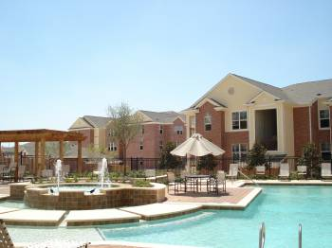
  Resort Style Pool
  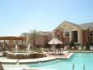 | 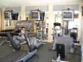 | 
  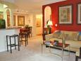 | 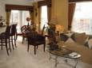 | 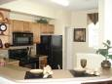

RENTAL FEATURES

Air conditioning | Double crown molding | Fireplace in select apartments
Walk-in closet | Spacious floorplans | Dining room
Cherry Cabinets | Black on Black appliances | Stove/Oven
Microwave | Washer and Dryer Provided | * Linen and pantries in most
Balcony, Patio, and Sunroom | Resort Style Swimming pool | Jacuzzi/Whirlpool
Cable-ready | High-speed internet available

COMMUNITY FEATURES

Assigned Garage parking | Assigned Carports | 24 Hr Game Room
24 Hr Business center | Clubhouse | 24 Hr Fitness center
Swimming pool(s) | Sauna/Spa | Gated property
New property (< 5 years) | Wheelchair access | * Open Parking available

LEASE TERMS

12 month leases. Ask about short term options

WWW.gables.com

 | Top of Form
  Contact info:
  Saira, Stacy, Amanda or Candie
  A Gables Residential Community
  972.906.8890
  COME IN TODAY AND RECEIVE $199 DEPOSIT/APP/ADMIN SPECIAL!!!

Equal Opportunity Housing

